**Setting Environment Variable for Cucumber in RubyMine 5.4.2**

Follow the below to set user defined ENV (Environment variables) for a single feature file in RubyMine 5.4.2 :

1. Launch RubyMine and open the project
2. Go to Run >> Edit Configuration…

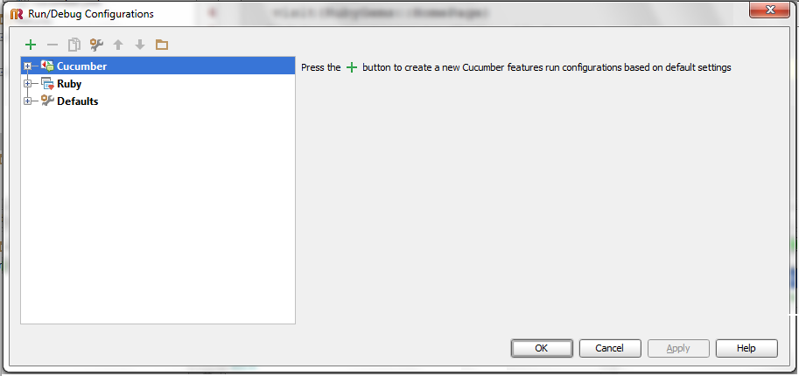

1. If you want to set ENV for a single feature file, then click the ‘+’ plus symbol and select ‘Cucmber’ option

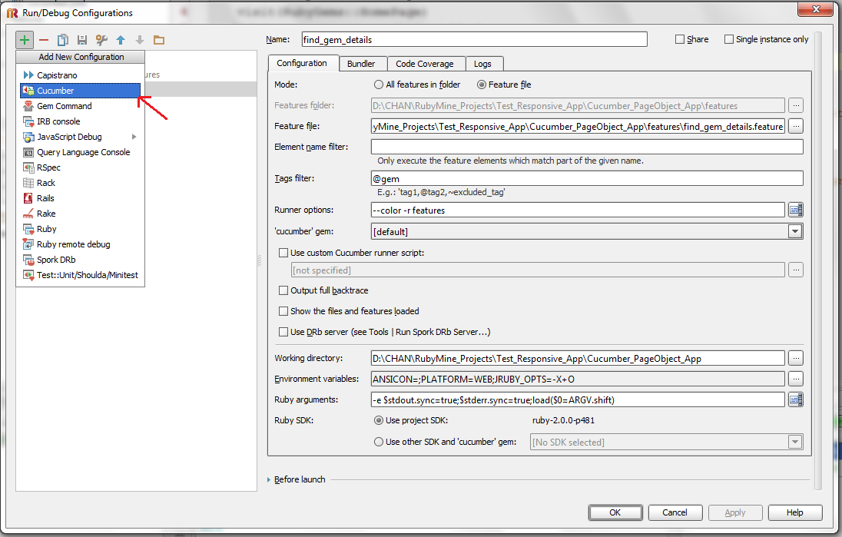

1. Fill in the mandatory fields (marked in the below image with red arrow)

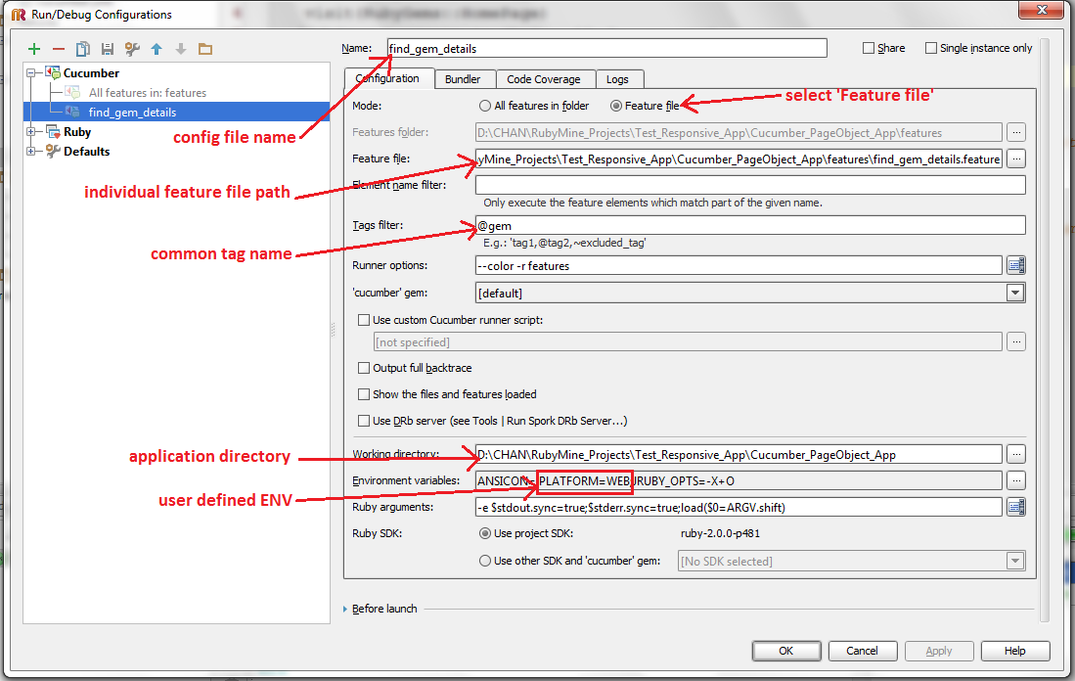

1. For setting ENV click the button (…) with three dots and click ‘+’ green colour plus button and then type the user defined ENV in key-value pair(s)

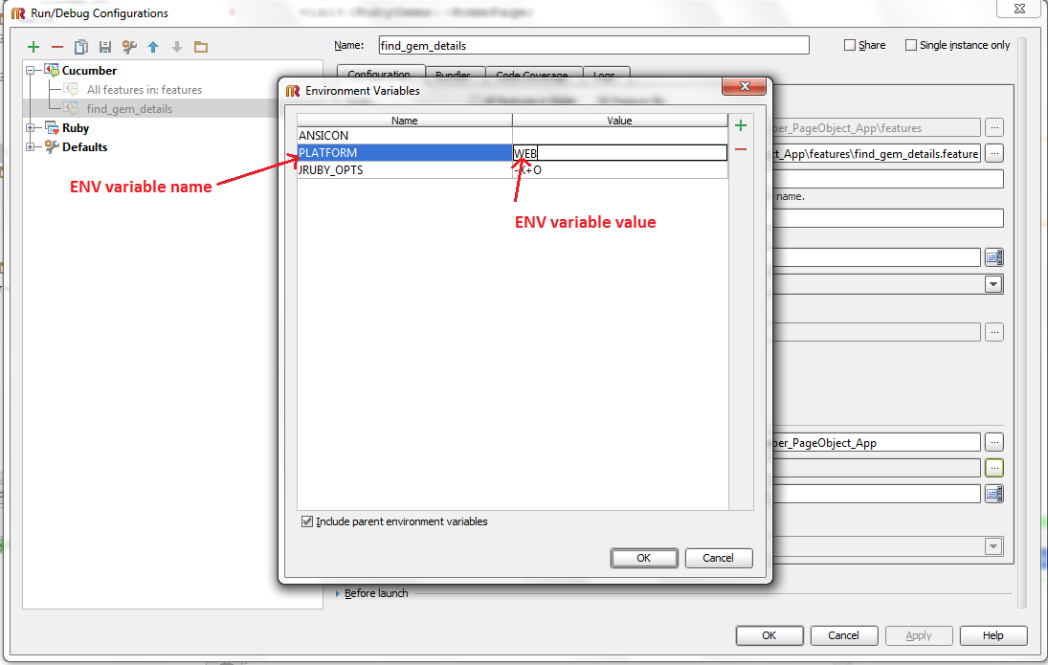

1. Then click ‘Apply’ button and then click ‘Ok’ button.

Note : the tag name (here @gem) is applicable for that specific feature file only and this settings will not apply for other feature files with the same tag same as we have given the path for only one file in the ‘Feature file’ field and hence applies to only one feature file.

**When you want to apply same config settings for all the feature files the follow the below steps :**

1. Launch RubyMine and open the project
2. Go to Run >> Edit Configuration…
3. Expand ‘Defaults’ and select ‘Cucumber’
4. Fill in the mandatory fields (marked in the below image with red arrow)

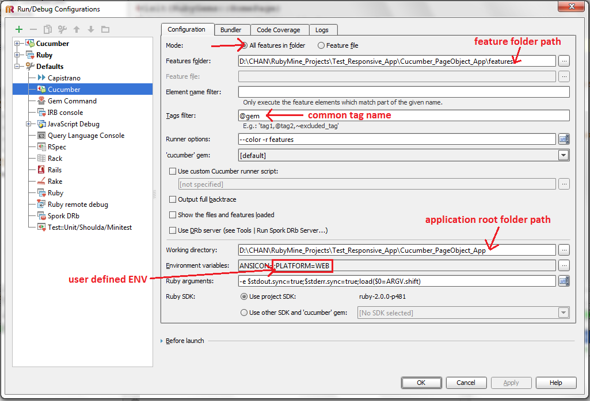

1. For setting ENV click the button (…) with three dots and click ‘+’ green colour plus button and then type the user defined ENV in key-value pair(s)



1. Then click ‘Apply’ button and then click ‘Ok’ button.
2. Then you can access the ENV within the entire application (i.e, it is visible to all files under cucumber application).